


Documentation

Courier Management System
Supervisor : | Sir Hassan
Batch : | 2301B
Group : | Courier Management System

Team Member:
Nimra Muhammad Asif (Student1447550)

Table of Content

Acknowledgement ……………………………………………………………………………... 03
Synopsis ......……………………………………………………………………….. 05
Purpose .....….………………………………………………………………………. 07
Requirement Specification ..….…………………………………………………………… 08
Module Description ...……………………………………………………………………….. 11
Wire Frames ………..…………..……………………………………………………………….. 16
Task Sheet …………………...….……………………………………………………………. 24
Validations & Submissions ..……………………………………………………………….. 25
ER Diagram ….…………..……………………………………………………………….. 27

ACKNOWLEDGEMENT

The first, I would like to express my special thanks of gratitude to my teacher SIR HASSAN who helped a lot in finalizing this project within the limited time frame, valuable counseling and assistance for the accomplishment of this project.
Secondly, I would also like to thanks the e-project team at Aptech Head Office, who gave me the opportunity to do this interesting and wonderful project Courier Management System.
Thirdly, I also thank the e-project team for giving this task to me.
Following are the benefits of this Project:
• Re-enforcement of skills happens in the experimental learning process.
• A mentor, ensuring that I do not get drifted, constantly guide me.
• It gives me a lot of confidence to face an interview as I have worked on a project. I can explain virtually everything on the subject which I have learnt.

SYNOPSIS

The Courier Management System (GoCourier) web Application is an online platform to designed to streamline and enhance the efficiency of courier handling for organizations currently managing the process manually. Recognizing the challenges faced in maintaining records and providing timely information to customers, this web app aims to automate and simplify the tracking and handling of couriers.
This web App main purpose is courier-related tasks by automating processes such as record-keeping, tracking, and communication. This reduces human errors, enhances accuracy, and improves overall efficiency.
Provide real-time tracking capabilities for couriers, ensuring that both organization staff and customers can access up-to-date information on the current status.
Offer comprehensive reporting and analytics tools that provide insights into courier trends, delivery timelines, and other key performance indicators. This enables organizations to make informed decisions, identify areas for improvement, and optimize their courier management processes.
The goal is to make the system accessible and easy to use, promoting widespread adoption within the organization.
Streamline the storage and retrieval of courier records, enabling quick access to historical data. This feature eliminates the need for manual record-keeping, reducing the risk of data loss and facilitating better organization-wide record management.

PURPOSE
The proposed web app will help to manage customer information, app billing, print courier history, register their self.
Courier management web application will be a comprehensive and complete application will be able to manage all its operations and also the tracking and manage delivery info all registered consignments or packages, manage customer related information. The web app provide necessary info of status. Admin will update the details of both sender and receiver include status of booked package or consignment. Admin will register the Agents.
Admin have all control authority to approve the user couriers as the status of pending into approve.
User can track their courier through online site and print their courier history by their tracking id.

REQUIREMENT SPECIFICATION
To popularize our Courier Management web App.
I have listed out the few points which I want to be their in web App.
Here are list to be design in the project.
In this web App there are three system Modules which are Users, Admin, Agent.

Users Module:

- Home page: should contain Menus like Home,
Tracking, About Us, Contact Us, Register, after register users have options to Login or then Logout.

- Tracking page: After login user can track their courier or see their courier status, courier history with their courier product image, bill & all information and can print this.

- About us page: Describe about the information of Courier Management Web App.

- Contact us form: (to take the details of user )
Like,
- Name
- Email
- Phone Number
- Feedback or Message (about our web App).
Admin Module:
Admin have a dashboard which can only use Admin. First he have to login by their email address or password to access the system. In this dashboard he has an options are:
- Login
- Create Agent city wise login
- Manage Agents Record (Update / Delete)
- Manage customer details
- View all Registered Users
- Add New courier
- View all courier details
- Pending Couriers
- Approve Couriers
- Denied Couriers
- Can approve or deny all Pending Couriers which will inserted by Agents.
- Update/ delete courier
- Track Users Couriers by users tracking id.
- View Users Contact Information (Message / Feedback).
- Status count
- Download all Approved Orders (XLSX).

Agent Module:
- Login
- Add New courier
- View all courier details
- Download approve couriers details (XLSX).
Module Description:
- Admin Login
- Admin will have his/her own login details (email address, password) to access the
system.

- Add Agents - Admin
- Admin will register all Agents (insert all agent information like Agent Name, Password for login, Email, Salary, Contact Number, City) and then he will give Email and Password to Agents then Agent can just login by this email or password to access their dashboard.
- Admin can view all Registered Agents information.
- Can Update / Delete Agents.

- Create Bill – Admin , Agent
- They can create a Courier Bill after logging in. Bills contain the details of sender, receiver, courier product image, courier weight , auto generated price according to weight, receiver city, auto generated delivery charges according to receiver city, delivery date, sender address, receiver address and overall auto generated total cost which will be sum of price + delivery charges, but they can change this prices I just created a code for total cost and delivery charges for saving their time.

- When Admin add courier so it will be inserted in Approved table and admin can view this approve orders on their Approve Couriers page with the status of Approved.

- When Agent add new couriers from their dashboard , So it will be inserted in User Couriers table as a status of Pending with their IDs and it will be shown on Admin Dashboard on the page of Pending Couriers with the status of pending and agent name.

- When Admin will be approve that pending couriers after this approval by Admin it will be shown on Agent Dashboard according to their Agent IDs on the page of courier details.

- After Approved couriers it will shown in Approved Couriers with the further columns which are Added by and Agent Id.

Note: After Admin Approval
- When Admin will be insert couriers So it will auto inserted Added by ‘Admin’ and when Agent will insert couriers So it will auto inserted Added by ‘Agent’ + (in Agent Id Column) it will auto inserted this Agent Id.
- Admin can deny pending couriers if he deny couriers so it will not be shown on Agent Dashboard.
- He can also approve the deny couriers on Users Request or he can delete also.

- Update / Delete Courier – Admin , Agent
- They can also update the Bill with the entries and if there is any modification. Agent can view the list of approved courier details according to their location, which is inserted by them.
- They can track Couriers also by User tracking id.
- Admin can download all Approved Couriers date wise, city wise (XLSX).
- Agent can download Couriers date wise, city wise (XLSX) which will be approved by Admin but according to their id 0r location (can download or view just his inserted couriers not all).

- Manage Customer details - Admin
- He can manage all the Customer Details in a separate and secured page.
- View all Registered Users.
- View all Users contact details (User Name, Email, Contact, message / feedback).

- Reporting
- Reports of all the Bill can be viewed by the admin of the system.

- Logout
- At last they can logout if they have done with their actions on the dashboard.
- User Login
- Track Courier
- User can see courier history by using their consignment tracking id.
- Courier status
- Print
- User can print tracking details
WIREFRAMES
Award Page
Concert Page
Gallery Page
FAQs Page
About Us Page
Contact Us Page
eryy56u56u6
Contact:918039182
TOP LAYOUT
Logo
Bottom Layout

Background Image
Home Tracking About Us Contact Us Register
Email:gocourier423@gmail.com

Footer

Home Page

About us Information

Steps

Delivered
Wait
Order

Product Delivery Info

Owl Carousel

Contact button
Get in Touch

Tracking Page:

Track Courier
Track your Courier
Enter Your Tracking Id

After Tracking

Courier Details
Product Image

About page:

About us Info

Contact Us Page;
Get Into Touch
Send
Message::::
Username:
Phone:
Email:

Registration Form:
Name:
Sign Up

Email:

Password:

Confirm Password:

Already have an account? Sign in
Register

Login Form:

Email:
Login

Password:

Forgot Paassword
Login
Don’t have an account? Sign Up
Login as an Agent? Log in

Admin Dashboard:

Admin Profile picture & Name
Admin
Logout
GoCourier
Dashboard
- Agents
- Add new agents
- Manage agents

- Users
- Registered Users
- Contact us Details

- Courier
- Add new courier
- Track Courier

- Actions
- Pending Couriers
- Approved Couriers
- Denied Couriers

- Settings
- Logout

Agent Dashboard:
GoCourier
Dashboard
- Agents
- Add new agents
- Manage agents

- Courier
- Add new courier
- Track Courier

- Orders
- Couriers Details

- Settings
- Logout

Agent Profile picture & Name
Agent
Logout

TASKSHEET
Project Ref .No: Ep |  | Project Title | Date Of Preparation Of Activity Plan
No. | TASK | COURIER  -  M  A  N  A  G  E  M  E  N  T  -  SYSTEM | Actual start date | Actual Days | Team-Mate  Name
O1. | Template Integration | COURIER  -  M  A  N  A  G  E  M  E  N  T  -  SYSTEM | 05  -  J  A  N  U  A  R  Y  -  2  0  2  4 | 30  -  D  A  Y  S | Nimra Asif
02. | Tracking Page | COURIER  -  M  A  N  A  G  E  M  E  N  T  -  SYSTEM | 05  -  J  A  N  U  A  R  Y  -  2  0  2  4 | 30  -  D  A  Y  S | Nimra Asif
03. | Contact Form | COURIER  -  M  A  N  A  G  E  M  E  N  T  -  SYSTEM | 05  -  J  A  N  U  A  R  Y  -  2  0  2  4 | 30  -  D  A  Y  S | Nimra Asif
04. | Registration/ Login Form | COURIER  -  M  A  N  A  G  E  M  E  N  T  -  SYSTEM | 05  -  J  A  N  U  A  R  Y  -  2  0  2  4 | 30  -  D  A  Y  S | Nimra Asif
05. | Jet Stream for Users /  Custom Login for Agents | COURIER  -  M  A  N  A  G  E  M  E  N  T  -  SYSTEM | 05  -  J  A  N  U  A  R  Y  -  2  0  2  4 | 30  -  D  A  Y  S | Nimra Asif
06.. | Admin Dashboard Integrated + Connected to Database + Complete all Requirements | COURIER  -  M  A  N  A  G  E  M  E  N  T  -  SYSTEM | 05  -  J  A  N  U  A  R  Y  -  2  0  2  4 | 30  -  D  A  Y  S | Nimra Asif
07. | Agent Dashboard Integrated + Connected to Database + Complete all Requirements | COURIER  -  M  A  N  A  G  E  M  E  N  T  -  SYSTEM | 05  -  J  A  N  U  A  R  Y  -  2  0  2  4 | 30  -  D  A  Y  S | Nimra Asif
08. |  | COURIER  -  M  A  N  A  G  E  M  E  N  T  -  SYSTEM | 05  -  J  A  N  U  A  R  Y  -  2  0  2  4 | 30  -  D  A  Y  S | NImra Asif
09. | Documentation |  |  |  | Nimra Asif

Validations & Submissions:
- Validations
VALIDATIONS | OPTIONS
Fields in form should be not null  - (Contact Us Form / Register / Login Form )  In Admin Dashboard:  - Add new Agents Form also should be not null  In Admin – Agent Dashboard:  - Courier Form Fields should be not null | Everything is validated

- Submissions:
PARTICULARS | YES | NO | COMMENTS
Do all the pages open | ✔ | - | But for opening Tracking page User should be logged in
Are all routes working? | ✔ | - | -
Are the web page contents devoid of spelling mistakes | ✔ | - | -
Are the page color as per | ✔ | - | -
Admin Dashboard:
Do all the pages open | ✔ | - | -
All routes protected | ✔ | - | -
View all Users Record / Agent Records from Database | ✔ | - | -
Update / Delete / Approve / Deny / Pending | ✔ | - | -
Add new Courier / Track Couriers | ✔ | - | -
Agent Dashboard:
Are all routes working? | ✔ | - | -
View all Approve Couriers as per their id | ✔ | - | -
Add new Courier / Track Courier | ✔ | - | -
Dashboards have Logout Option | ✔ | - | Both Have

ER Diagram:

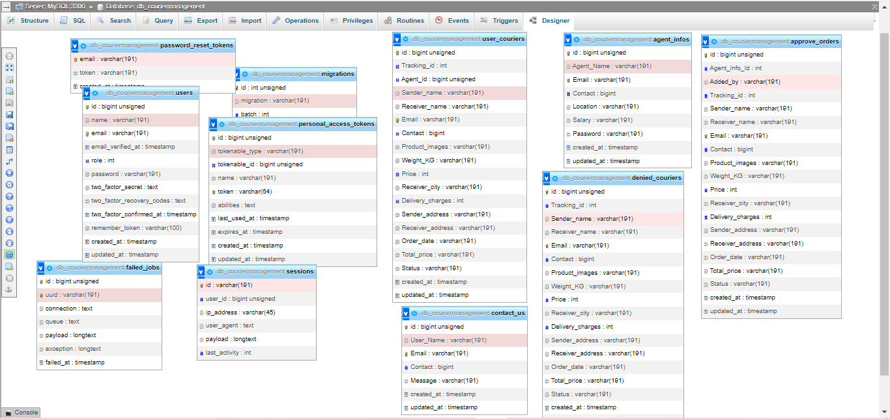

user_couriers table and agent_infos table are connected to each other



